Jacob Konicke

Overview/usage

The purpose of this program is to be something to kill time with, This program has the user take pictures of various objects that can be found almost anywhere. This program will require the user to have internet to connect to use the google api, a camera to take pictures and an android phone. I made this program to meet the homework requirements but also go a little farther because as I was thinking of how to make this program I was able to think of some fun things I could do with it.

When the user starts this program they are met with a simple screen that has only one button that says start:

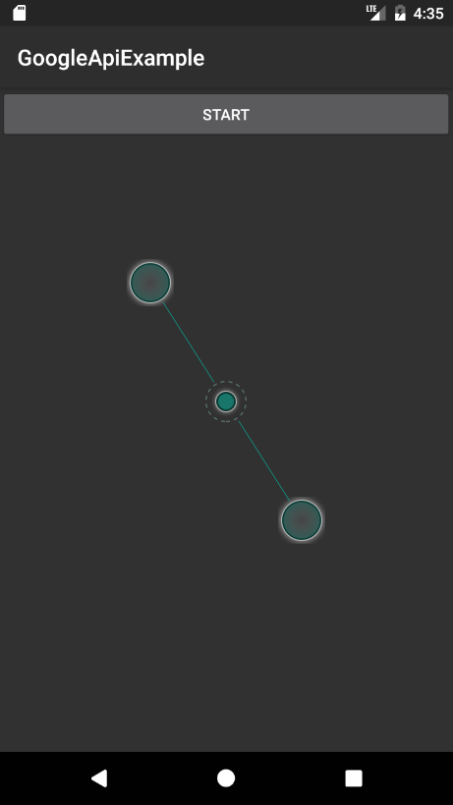

After they click the button they are brought to a screen with another button at the top that says Open Camera with a text box a little farther down the screen that asks the user to take a picture of some object. Once the user presses the open camera button they are brought to their camera:

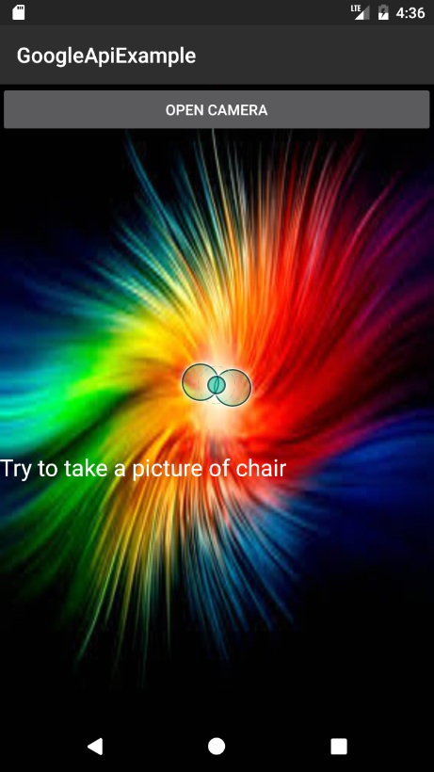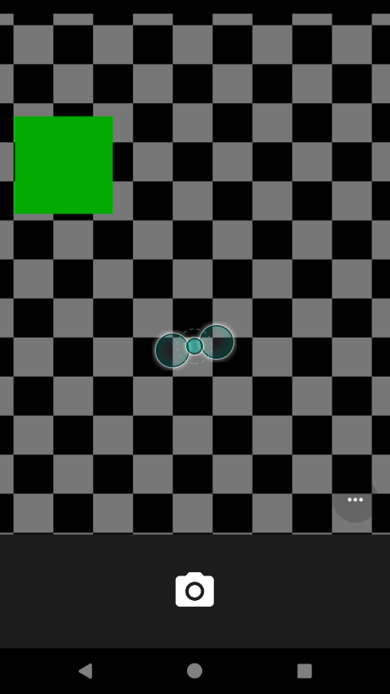

Once they take a picture They will see the photo and a check mark, once they hit the check mark they are brought to the third screen of the app:

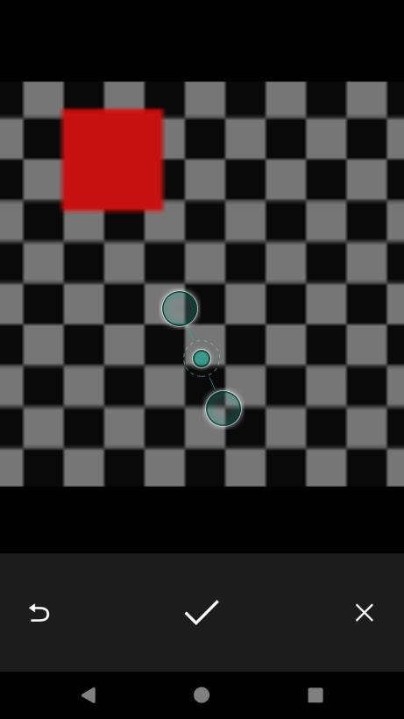

Once you reach the third screen you will see a text box telling you whether the google api's top ten results are the same as what you were asked to take a picture of. If one of the top 10 items guessed by the google api is the item you needed then you are given the message “Correct that is (item you had to find)”, if it didn’t find the item it tells you, “Sorry but the Api didn't identify your picture as (item you had to find)” if you wanted to repeat the process you can press the button that says "Push me to get your next item to find a picture of.". After you push the button you are brought back to the screen with the open camera button and the text has been changed to the next item you should take a picture of.

